Project Design Phase-II
Technology Stack (Architecture & Stack)

Date | 30 September 2026
Team ID | Swtid-2026-2843
Project Name | AI-Weather-wise API
Maximum Marks | 4 Marks

Technical Architecture:
User Interface → Backend/API → Weather API → AI Prediction Engine → Database → Weather Forecast & Alerts
Example: Order processing during pandemics for offline mode
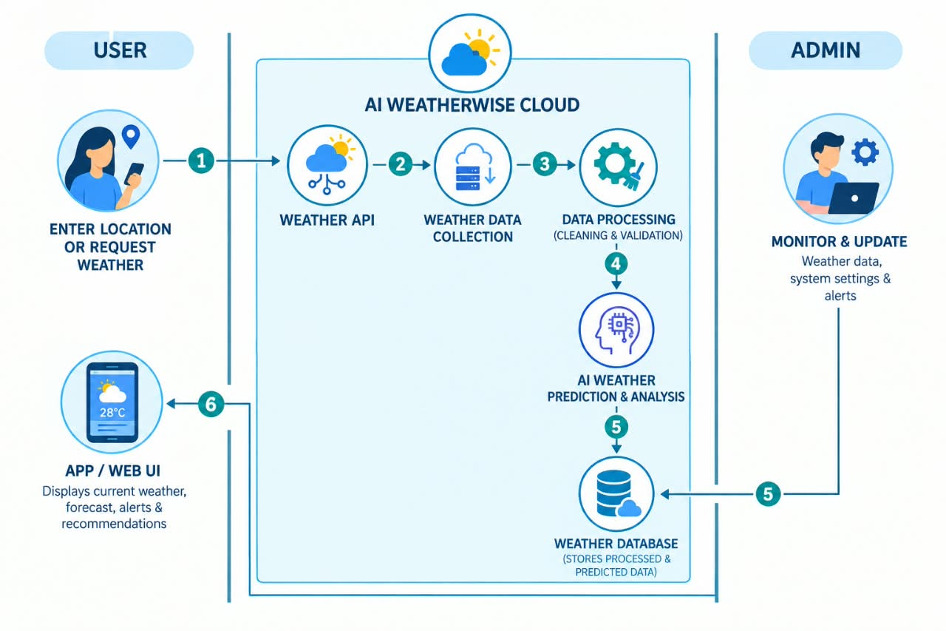

Table-1: Components & Technologies:
Here is the condensed, compact version of Table-1: Components & Technologies designed to fit tightly in smaller document layouts, slides, or compact report sections:

S.No | Component | Description | Technology
1 | UI | Voice call intake & Admin dashboard | Toll-Free Voice, React.js / Web UI
2 | Core Logic | Orchestrates audio & pipeline flow | Python / Node.js Microservices
3 | Speech Service | Transcribes voice calls to text | IBM Watson Speech to Text (STT)
4 | NLU / NLP | Translates & extracts order intents | IBM Watson Translator & NLU
5 | Local Cache | Staging storage for offline processing | SQLite / Redis Cache
6 | Cloud DB | Central store for verified orders | IBM Db2 on Cloud
7 | Storage | Audio recordings & log storage | IBM Cloud Object / Block Storage
8 | Ext. API 1 | Real-time weather forecasting | Weather-wise / IBM Weather API
9 | Ext. API 2 | Identity verification service | Identity Verification API
10 | ML Model | Custom domain terms & dictionaries | IBM Watson Knowledge Studio
11 | Cloud Infra | Hosting & container deployment | IBM Cloud, OpenShift / Kubernetes

Table-2: Application Characteristics:
In an AI weather-wise / Voice-Based Order API architecture, application characteristics define essential operational parameters: leveraging Open-Source Frameworks for agility, Security Implementations (encryption, IAM) for data protection, a Scalable Architecture (microservices) for handling demand, high Availability (load balancers) for uptime, and optimized Performance (caching, low-latency processing).

S.No | Characteristics | Description | Technology
1. | Open-Source Frameworks | Open-source technology frameworks, libraries, and applications can be built and developed. | Python / Node.js, REST APIs
2. | Security Implementations | Security measures such as access control and cloud security standards can be implemented | SHA-256 Encryption, IAM Controls, TLS/SSL, OWASP Top 10 guidelines
3. | Scalable Architecture | System scalability can be achieved using a microservices-based architecture. | IBM Cloud Microservices, Node.js / Containerized Services
4. | Availability | High availability can be achieved through cloud server deployment and load balancing. | IBM Cloud Infrastructure, Cloud Load Balancers, Distributed Servers
5. | Performance | High performance and rapid response times can be achieved through AI voice-to-text processing. | IBM Watson Speech to Text, NLU, Db2 Cloud Caching, CDN

